**Week 1**

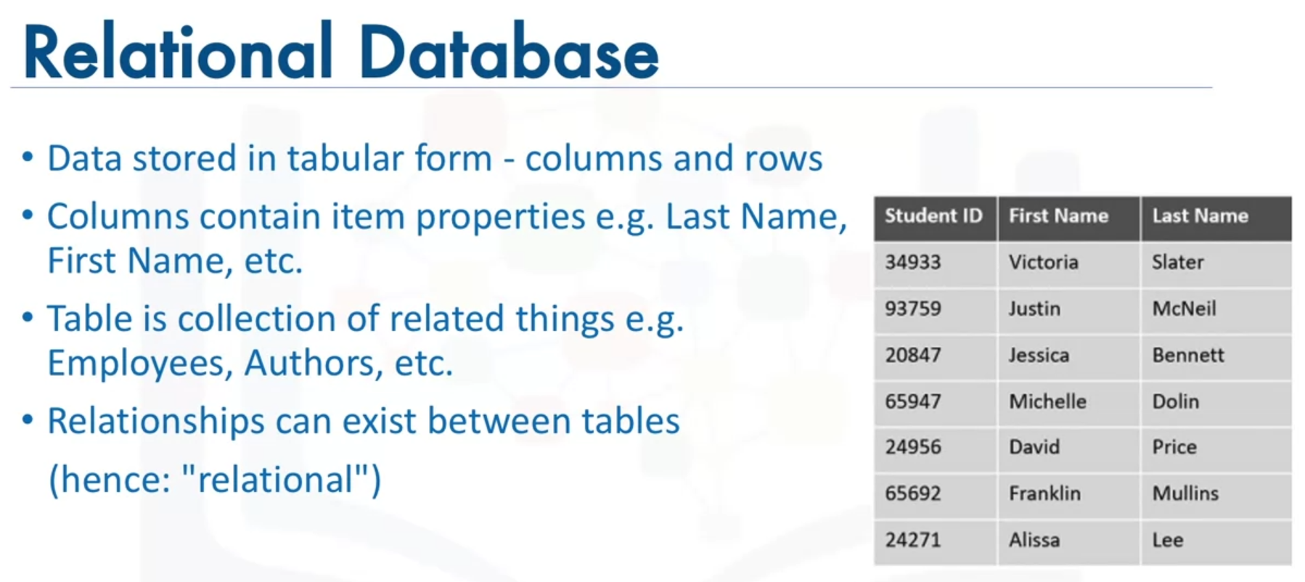

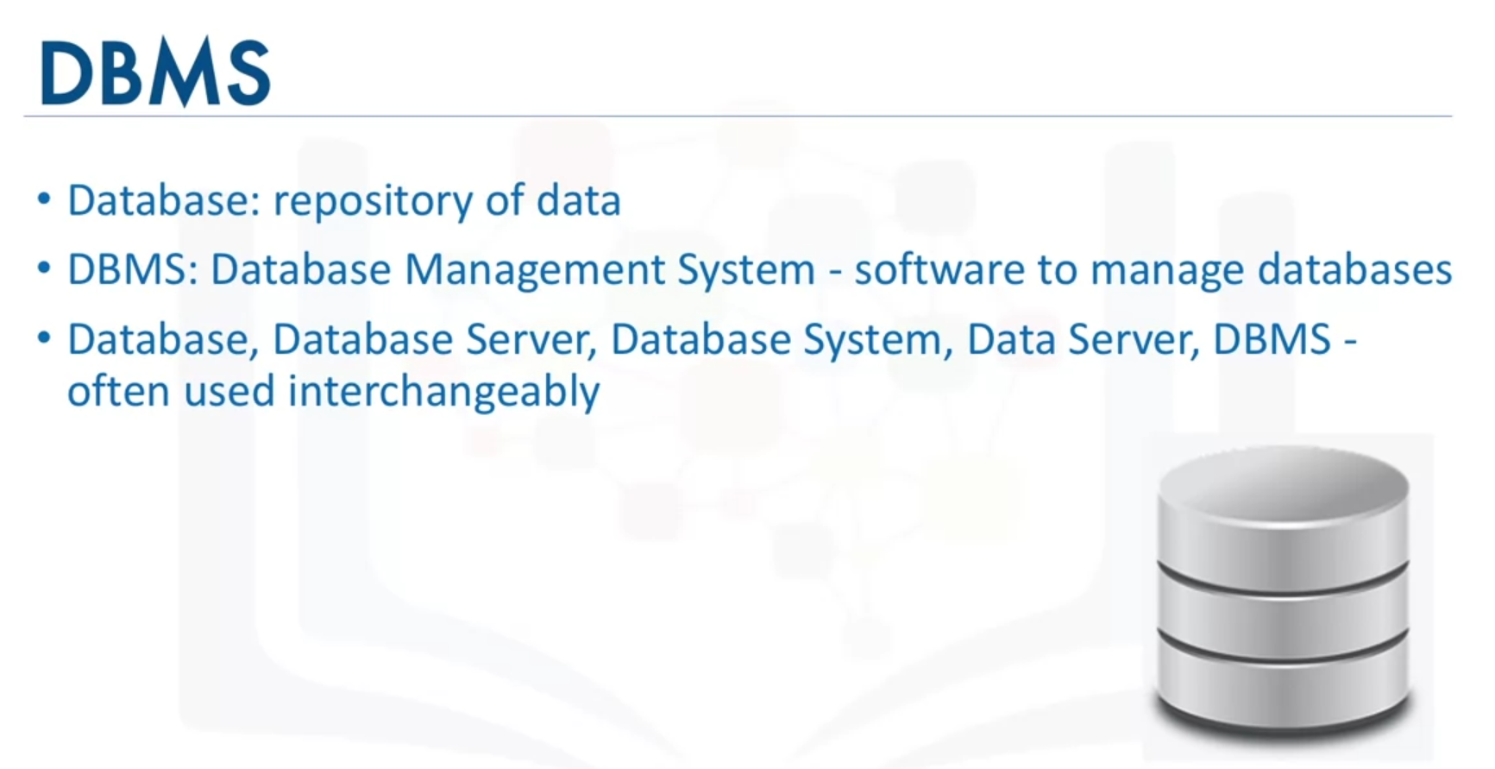

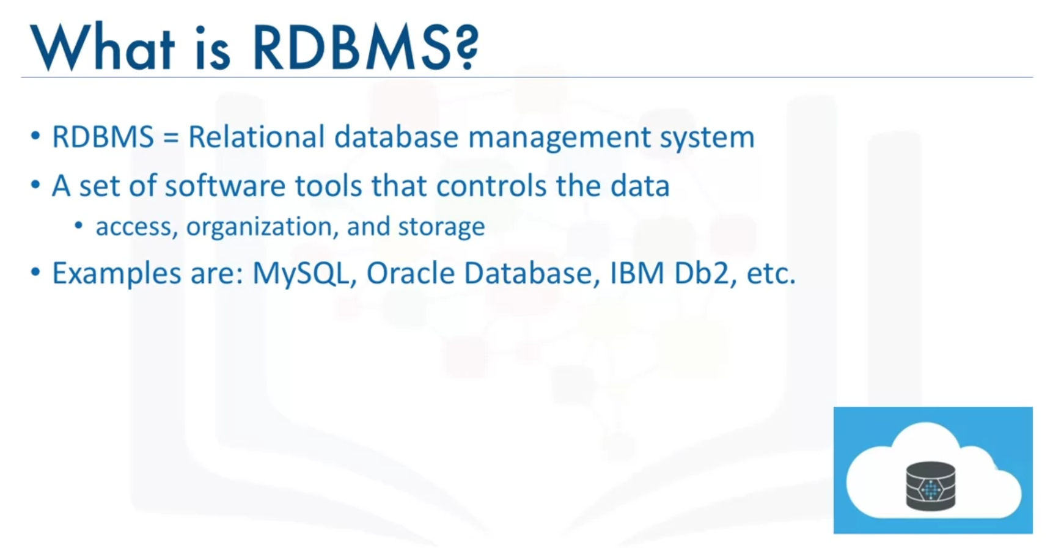



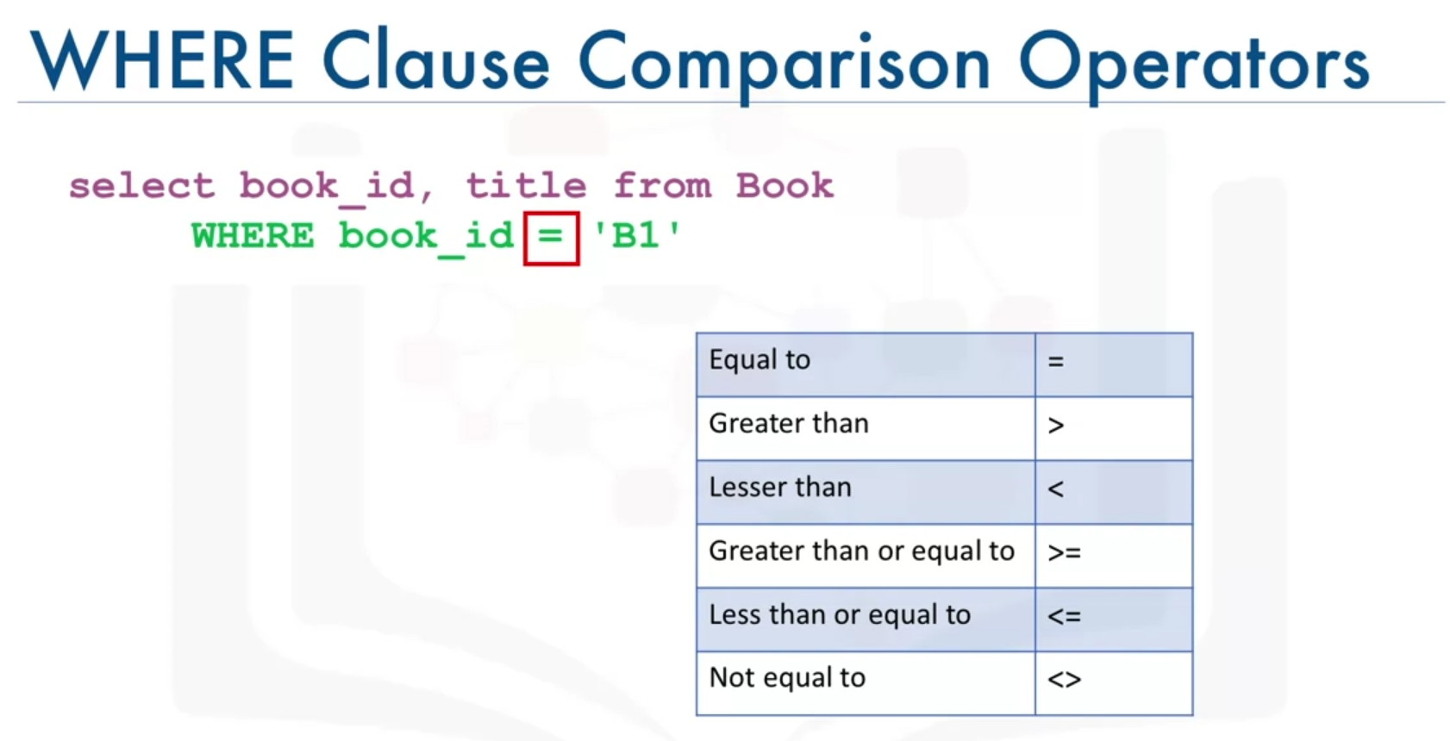

**Why is there a semicolon after the SQL statements?**

* Some database systems require a semicolon at the end of each SQL statement for execution. It is a standard way to separate one SQL statement from another which allows more than one SQL statement to be executed in the same call to the server. So, it is good practice to use a semicolon at the end of each SQL statement.

This time we want to retrieve a specific number of rows starting from a specific row in the table. Retrieve the first 15 rows from the “FilmLocations” table starting from row 11.

SELECT *

FROM FilmLocations

LIMIT 15

OFFSET 10